Appendix C

Y. Socol, M. Kanter, Y. Lasser, M.Volshonok

Terminal Capacitance and Voltage Stability

Internal FEL report # 36

1. Pick-up capacitor frequency response

In order to estimate the last values of fast changes of the terminal voltage, we use a capacitive pick-up probe (Van-de-Graaff Instruction sheet HVI-1016, see Appendix). The purpose of this report is to estimate quantitatively how fast the change should be to be represented adequately by the pick-up, and how low-frequency data should be interpreted.
The pick-up capacitor measuring system is sketched at Fig. 1. Appropriate electrical scheme is given by Fig. 2. Analysis of the latter (see App. HVI-1016) gives the following result for the voltage measured by the oscilloscope:

Vp.u.(ω ) = V_{T}(ω ) / [(1 + Cp/Cc) ² + ( ω R Cc)^{–2}] ^{1/2}
where Cc is the cable capacitance, Cp – pick-up capacitance (see Figs. 1,2) and R is the internal resistance of the oscilloscope.
As far as frequency response is considered and Cp<<Cc, the formula for Vp.u.(ω) depends on a single parameter: time constant τ=RCc. R is known to be R=1 MΩ, and Cc can be roughly estimated since the cable length and diameters are known. The latter estimation leads to Cc~1pF and τ ~ 1 ms. However, τ can be rather accurately measured by studying the ms-scale response of the capacitive pick-up to the short (~μs) current pulse of the e-gun. The measured value is τ =2.0 ±0.2 ms.

Fig. 3 shows the relative frequency response V(ω )/V(∞). One can clearly see that for frequencies above 1-2 kHz the response is already flat. Therefore pulses of 10–100 μs length are measured by the capacitive pick-up without distortions. If we want to measure longer pulses in the future, additional care should be taken.

In order to calculate the absolute calibration (i.e. the ratio between the terminal voltage change and the capacitive pick-up measurement) one should measure all the involved resistances and capacities. However, it is simpler and more accurate to make the absolute calibration by measuring the capacitive pick-up signal together with an independent measurement of the terminal voltage.

To make such calibration, we performed 2 series of measurements.
In the 1-st, an AC signal from a signal generator was amplified by a HV transformer and fed to the terminal via the short-circuit rod (the latter is routinely used to measure the charging current of the Van-de-Graff). The fed signal (1–3 kV) was directly measured by oscilloscope via standard HV divider. The pick-up signal (hundreds of mV) was measured by an additional oscilloscope. The experimental oscillograms are given in the Appendix II. Fig. 4 shows relative frequency response of the pick-up capacitor. The curve behavior fits well the time constant value of τ =1.2 ms. Fig. 5 shows absolute calibration. Assuming saturation at frequency of ~1 kHz, we obtain the following calibration factor:
V(terminal) / V(pick-up) = 12.5 kV / 1V for f >1 kHz .

In the 2-nd series, HV (0.5 –1.5 kV) from a DC power supply was fed to the terminal though the same rod by pulser (rise time less than 1 μs ), and the appropriate pick-up response was measured. The obtained calibration factor was

V(terminal) / V(pick-up) = 13.8 kV / 1V pulser measurements

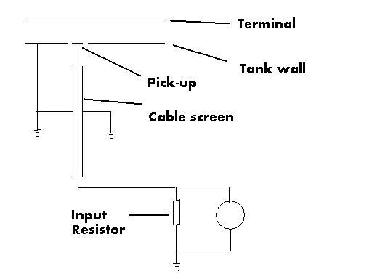

Fig. 1 Pick-up measurement sketch

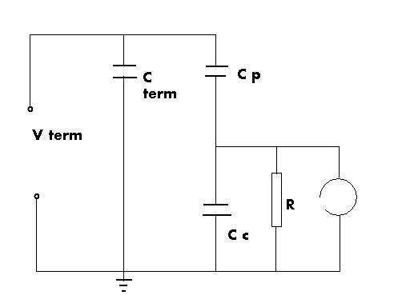
V (ω)

Fig.2 Pick-up measurement electrical scheme

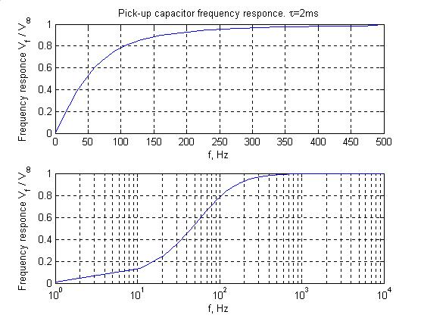

Fig.3 Capacitive pick-up frequency response for RC = 2 ms. Top: frequency scale up to 500 Hz. Bottom: frequency scale up to 10 kHz, showing saturation of V(f).

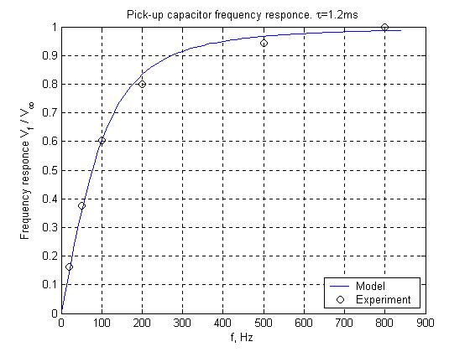

Fig. 4. Capacitive pick-up frequency response – experiment. Solid line corresponds to RC = 1.2 ms

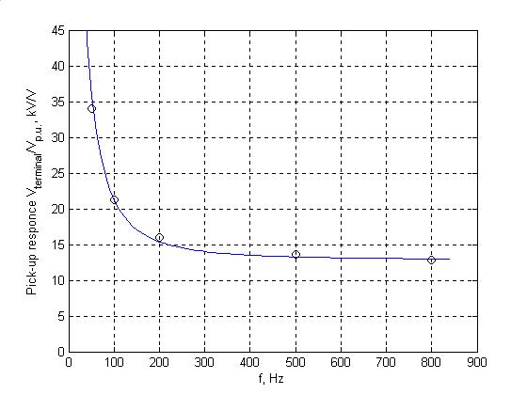

Fig. 5. Capacitive pick-up frequency response – experiment. High-frequency limit corresponds to 12.5 kV(terminal) / V(pick-up). Independently obtained (with pulser) high-frequency value is 13.8kV/V.

2. Terminal Capacitance

Having the pick-up capacitor probe signal calibration, we can now measure the terminal capacity. With zero transport through terminal (screen S2 in), 1.8A cathode current and 10 μs-long pulse, a pick-up voltage signal of 3.6V was measured. Using the above calibration of 13.8 kV/ V, this corresponds to a terminal voltage drop of 50 kV. The intercepted charge in this case is 1.8A*10 μs=18 μC, Consequently, the measured terminal capacity is

C(terminal) = 18 μC / 50 kV = 360 pF.

The latter value is in fair correspondence with previous measurements of the terminal capacity (internal report # 30 cites 330pF). It should be noted, however, that the obtained value of 50 kV terminal voltage drop at zero beam current transport, 1.8A cathode current, 10 μs pulse is considerably less than the previous estimate (125 kV was stated in FEL 2003 article).

3. Terminal Voltage Stability

Oscillograms of pick-up signal contain pronounced oscillations at frequencies 50Hz, 500Hz and higher. 50Hz frequency is most probably an artifact due to the grid interference the pick-up measuring line. The peak-to-peak signal difference is 15mV. If we suppose that it is real, namely, that this is a voltage fluctuation of the terminal, then using a probe calibration of 34 kV/V from Fig. 5 for f=50Hz, we obtain maximum (peak to peak) voltage fluctuation amplitude

ΔVp-p =500V, frequency region ~ 50Hz

Referring to the 500Hz frequency fluctuation, its amplitude is at most 10mV peak-to-peak. With the appropriate calibration from Fig. 5 this corresponds to peak-to-peak fluctuation

ΔVp-p =150V, frequency region ~ 500Hz

However, the most important voltage instability is at very low frequencies –fractions of Hz, i.e. seconds-long oscillations (really, the RC time constant for the terminal with C=360pF, R=12GOhm is about 5s). These oscillations cannot be measured by oscilloscope due to very low pick-up signal. The direct measurement with a DVM (digital voltmeter) yields terminal voltage fluctuations of about

ΔVp-p =15 ~ 20kV, frequency region ~ 0.1~0.5Hz.

Rarely after conditioning fluctuations are small down to ΔVp-p =4kV.
As ELOP simulations show (see Appendix I ), accelerating voltage deviation below 1kV would have an insignificant effect at least on the predicted spot size on S2. We can conclude therefore that high frequency terminal voltage instability (ripple) is unimportant for electron transport and should not be addressed in the development effort. However, 10kV terminal voltage trip has considerable influence on transport. Further efforts are needed: either the terminal voltage should be stabilized to at most ±2kV, or e-beam pulse should be synchronized with terminal voltage, i.e. e-pulse fired when terminal voltage passes the pre-given value.

APPENDIX I
Electron beam diameter VS terminal voltage

This Appendix deals with the voltage instability influence on the beam’s shape. Table 1 presents the results of ELOP calculations of the beam size as function of the terminal voltage at given quad currents as listed below. Beam emittance: 5π mm*mrad, diameter on S₁(–2411 mm): ∅=26 mm, convergence: fx=7.7m, fy=11.1m.

Quad currents:
Q1 | 0.780[A]
Q2 | –1.054[A]
Q3 | 1.465[A]
Q4 | –0.282[A]

Table 1. Start point S₁: Z= –2411mm; end point S₃: Z= 813mm
Terminal Voltage [kV] | Beam Diameter on S₃ [mm]  ∅_{X} ∅_{Y} |  | Maximal Beam Diameter –scalloping [mm]
1300 Fig 2 | 24 | 18 | 6
1350 (optimal) Fig 1 | 4.2 | 5.8 | 2
1400 Fig 3 | 14 | 24 | 8

Fig 1. 1350 kV, laminar propagation

Fig 2. 1300 kV, scalloping

Fig 3. 1400 kV, scalloping
