



מרכז ידע FEL למקורות קרינה ושימושים

המכללה האקדמית יהודה ושומרון באריאל

דו"ח התקדמות בנושא :

Compact FEL – Feasibility Study

פרופ' אברהם גובר
פרופ' יוסף פנחסי
ד"ר יהושע סוקול

דצמבר 2006

Compact FEL – Feasibility Study

Abstract

The performed study showed a principle feasibility of compact FEL IR source. Various technologies, including thermionic and photo-cathode electron gun, normal and superconducting accelerator cavities, were examined. A novel concept of FEL power repeater was developed.

The general FEL lay-out is given at Fig. 1a, and the typical electron beam structure – at Fig. 1b.
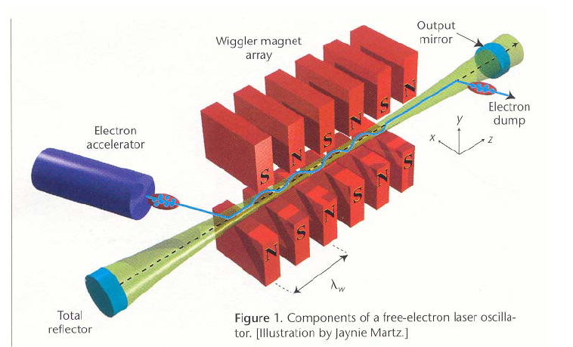

Fig. 1a General FEL lay-out.

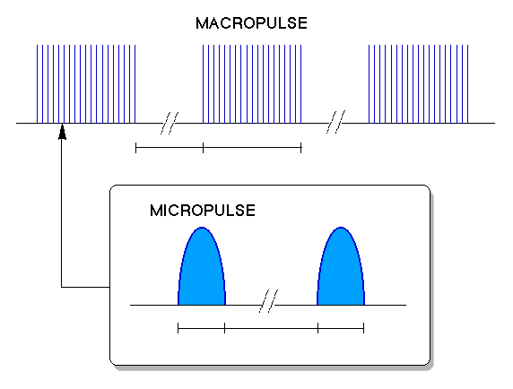
5-200 ms 10μs
20 ps 0.3-10ns 20ps

Fig. 1b Electron beam structure of RF Linac. Electrons come in ~20ps-long micropulses, which are grouped into ~10μs-long macropulses.

Accelerator technology is considered to be one of the main difficulties in the FEL technology. Therefore considerable effort was invested in verification of compact accelerator feasibility. For electron gun, thermionic and photo-cathode possibilities were examined. For accelerating structures, they may be superconducting or normal. Though no opportunity was rejected so far, superconducting accelerator with photo-cathode seems to fit most. Such compact accelerator already exists at BNL (Fig. 2).

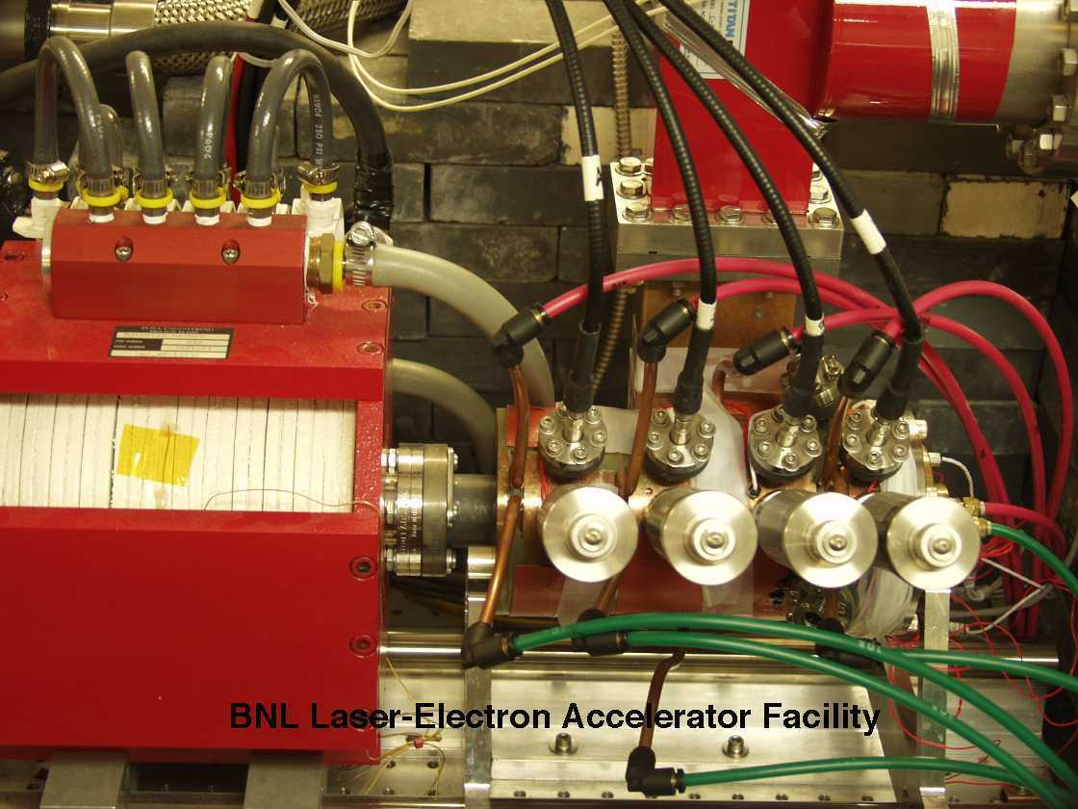

Fig. 2. BNL LEAF RF-gun. Length ~ 30 cm , Electron energy 9.2 MeV, RF power~15MW [Rev. Sci. Inst. 75, 4359-4366 (2004)]

Short undulator limits the achievable FEL gain, therefore the radiation build-up time is too long. In order to cope with this problem, a novel concept of FEL power repeater was developed. This concept is discussed in App. I. For power repeater a short but strong seed pulse is needed. Possible technology for achieving such seed pulse is described in App. II.

References

- A. Yariv. Quantum Electronics. NY, 1987 (3-rd ed.). Chapter 12.
- E. Jerby, A. Gover. IEEE J. Quantum Electronics, 21(7), 1041-1058, 1985.

Appendix I

FEL Power Repeater – decreasing the build-up time

For FEL gain values g of 20% and less (g<1.2), the time (and consumed e-beam energy) of radiation build-up may be very significant. Really, the (stored, or re-circulating) radiation power P(t) is
P(t)=P(0) exp(t ln(g) / τ),
where P(0) is the initial radiation power and τ is the round-trip time τ=2l/c. Therefore
t(build-up) = τ ln(P(t)/P(0) / ln g ~ τ ln(P(t)/P(0)) / ( g – 1).
E.g. effective round-trip gain of 20% leads to power build-up (9 orders of magnitude) time of about 0.75µs for 1m-long resonator. For effective gain of 2%, this time is about 7µs, which is close to the present upper limit value of macro-pulse duration (due to technology limitations).

The proposed power-repeater scheme enables to overcome the mentioned problem by omitting (or considerable shortening) the radiation build-up stage. Low gain operation demands high-Q resonators, i.e. is restricted by near-UV or longer wavelengths.
The concept is based on the fact that the present technology of optical lasers enables pulse compression to very high peak powers – on the account of pulse duration and duty cycle. It is proposed to use a single strong "starter" pulse from an external source to saturate the FEL oscillator, or at least to bring it close to saturation.

In what follows we restrict ourselves to most popular RF-accelerator driven FELs, where electron beam comes in ps-long micro-pulses. The FEL interaction looks like the following. The "starter" optical pulse (of near-saturation power) is caught by the high-Q optical resonator. Micro-pulse rate is synchronized, as usual, with the light round-trip time. The arriving electron micro-pulse interacts with the optical field, leaving part of its power to this field. It should be mentioned, that the optical gain value g cannot be higher than the small-signal-regime value g_{small signal}. If this released optical power is above the total round-trip power loss (including out-coupling) between 2 synchronized micro-pulses, this process will last as long as micro-pulses arrive.

Let us estimate now the power needed to saturate the oscillator. The saturated additional power ΔP is given by well known expression
ΔP = I U η(ext)
where η(ext) is the extraction coefficient η(ext)~1/2Nw (Nw is the number of undulator periods). Simultaneously, we can write
ΔP = P (g–1),
where P is the input optical power and g is the gain (as mentioned, g < g_{small signal}). Therefore
P = ΔP / (g–1) = I U / 2Nw(g–1).
This power P should be provided by the "starter" laser, if we want to saturate the oscillator immediately. For beam energy 10MeV, 20-period undulator, micro-pulse current 100A and 10% gain, this yields P=250MW (for comparison, the pulse power of 30ps, 30mJ/pulse Nd:YAG laser is 1000MW at 1.06 µm). If the "starter" power is not enough, it will take the oscillator some time to reach the saturation. However, this time is considerably less than in the case of starting from noise.

Now let us estimate the power out-coupling efficiency of the proposed scheme. The re-entered power is P g R=P g (1–T)(1–L), where T (transmission) is power out-coupling ratio, and L is the resonator round-trip loss. To obtain continuous operation, we need
P g R=P, i.e. g (1–T)(1–L)=1. The out-coupling T is restricted by the gain g and the round-trip loss L, always T < g–1:
T=1 – 1 / g(1–L).
The out-coupled power is therefore
Pout=P g T= g ΔP (1 – 1/g(1–L) ) / (g–1).
Leaving in Pout only the leading terms in respect to small parameters (g–1) and T, we obtain the out-coupling efficiency

η (out) = Pout / ΔP = ((g–1) – L) / (g–1).

E.g., for 10% gain (g=1.1) and 2% round-trip loss (L=0.02), the out-coupling is T=0.08 and η (out)=0.8; for 5% gain and 2% loss, η (out)=0.6 .

It should be mentioned that the proposed method is somewhat similar to the well-known concept of beam pre-bunching. The principal difference, however, is in the fact that pre-bunching demands applying EM power to the e-beam all the time, while in the proposed scheme it is applied to 1 (or several 1-st, if the micro-pulse rate is higher than the resonator round-trip frequency) micro-pulse(s) only.
Appendix II
IR source for FEL Power Repeater

First of all, owing to the short pulse, OPO is not practical, and you will
need either an optical parametric generator (OPG) or optical parametric
amplifier (OPA). OPG is simpler, since it requires only one pump, but is
worse in terms of spatial and spectral properties, and also in terms of
efficiency. OPA is better, but then 2 sources are needed, say a
Ti-Sapphire pump at 840 nm and a Nd:YAG or Nd:YLF signal at 1064 nm. They
need to be synchronized to within 1 psec, which is 300 microns in air.
This is not trivial, but with a delay line with micrometric resolution
should be possible.
As for laser pump sources, we assume that one will need to order a special
system (e.g. from "Coherent"). Looking at some standard systems by
commercial laser companies, the values are reasonable. For example, a Ti:Sapphire Spitfire Pro amplifier made by Newport (Spectra Physics) provides 2.25 mJ per pulse, with pulse width of 2 psec and repetition rate 1kHz, in the wavelength range
750-840 nm. Coherent offers a Ti:Sapphire amplifier that provides up to
15J(!) per pulse at 1 psec. In both systems it is a mode locked laser,
amplified by an external amplifier. So it seems that a Ti:Sapphire source can be used as the pump of the OPA at 840 nm, and a Nd:YAG or Nd:YLF laser can be used as the signal of the OPA.
Other issues include selection of suitable nonlinear crystal, and getting
good efficiency without optical damage in the nonlinear conversion
process. The efficiency is limited by the quantum efficiency. With good design, one may approach these values.
Project cost estimations are not very accurate at this point. We think
that the main cost is the laser. For a laboratory laser, the cost is
definitely much more than 100 k$. In addition one needs to design and
build the OPA. As a rough estimate, the OPA cost includes nonlinear
crystals (say 5 -10 k$), optics and mechanics (another 5k$), 3 months of
engineer and 6 months of skilled technician. It may be possible that the
laser company will also make the OPA, as a turn-key subcontractor.

