Appendix B-2

New wiggler magnets measurement
Malachi Harpaz, Prof. Asher Yahalom, Efraim Mengisto

Brief review
39 magnets were bought recently in order to be used as spare parts for the F.E.L.'s wiggler. In this report we'll show a measurement setup for these magnets.

The main principle of the F.E.L. (Free Electron Laser) is a transportation of an electron beam through a periodic magnetic field, implemented by a wiggler. The wiggler contains series of magnets, applied in a pre-calculated structure in order to build the certain magnetic period.
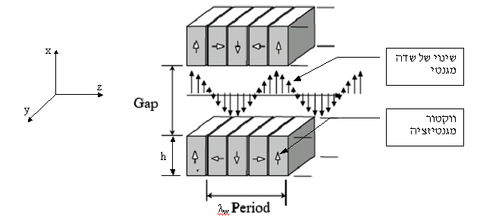
Magnetic
vector
Changes in the magnetic field
Fig.1 shows a Holbach wiggler.

After calculating the magnetic field required for the magnets, we can place them in the right structure; however, the magnets come from the manufacturer with an average and a certain deviation from the firm request. If unconsidered, this deviation can cause a wrong action of the wiggler. Therefore each magnet ought to be measured and classified by its real characteristics. The result will be a specified place for each magnet in order to form the most accurate magnetic structure in comparison to the pre-calculations.
Objectives:
- To measure each magnet's characteristics – magnetization direction and magnetic field.
- To verify that the new magnets are compatible to the company's specifications and the firm request.
- To test a new measurement device for single magnet.

The measurement setup:
- Gauss meter that measures magnetic field with a hall probe.
- A new device that holds a single magnet and a hall probe in accurate positions.
- The magnetic field that was measured is in Bz direction, as shown in fig. 2 and 3.
magnet
5.5 mm to the center of the probe
11.1
Hall probe
11.1
Bz
150.53 mm from the edge of the probe to the edge of the magnet
Fig. 2 – the measurement setup.

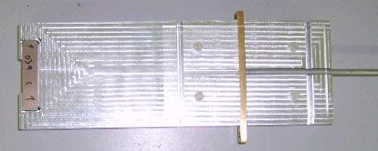
measured magnet
Hall probe - fixed
in a special device
150.53mm

fig.3 – a picture of the measurement setup
The measurement process:

- The magnets were divided into 3 groups (A, B or C) by their size and material. Each magnet got a number and a mark that contains the magnetization direction and the "name" of the magnet (group and number).
- The Gauss meter was calibrated, the hall probe was placed in the device, and the background magnetic field was measured.
- After placing a single magnet in the device, a magnetic field in Bz direction was obtained and recorded.
- The magnetic field that was recorded is the field in a certain place, far from the magnet. In order to know the real residual magnetic field inside the magnet we need to use a simulation program to calculate it. The simulation program integrates the geometrical parameters of the measurements setup and the magnet's size, and gives a factor that coordinates between the measured field and the actual magnetization as followed : $\vec{M}=\frac{\vec{H}}{H_{z}}$,
M= Actual magnetization
H= Measured magnetic field
Hz= The matching factor

Main results (in KG):

Br statistics for group A:
Manufacturer's certificate [kG] | Actual [kG]
10±0.2 | 10.103 | Avg
 | 0.077 | deviation

Br statistics for group B:
Manufacturer's certificate [kG] | Actual [kG]
10±0.2 | 9.56 | Avg
 | 0.1294 | deviation

Br statistics for group C:
Manufacturer's certificate [kG] | Actual [kG]
8±0.2 | 8.2 | Avg
 | 0.0567 | deviation

Conclusion:
The actual measured Br's satisfy in comparison to the manufacturer's certificate.

Group A

Calculated  Br [KG] | Measured field [KG] | Magnet name
10.11 | 1.179 | - A010
10.15 | 1.184 | - A011
10.25 | 1.195 | - A012
10.20 | 1.189 | - A013
10.08 | 1.175 | - A014
10.12 | 1.18 | - A015
10.07 | 1.174 | - A016
9.97 | 1.163 | - A017
10.04 | 1.171 | - A018
10.03 | 1.17 | - A019

Measurement statistics:

Average – 10.1 KG
Std deviation – 0.077 KG

Group A specifications (manufacturer's certificate):
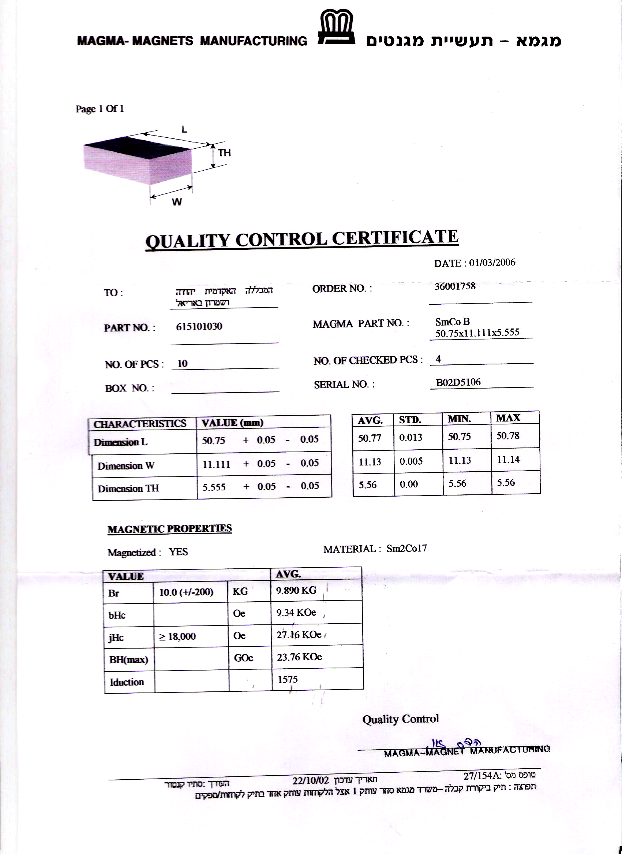

Group B

Calculated  Br [KG] | Measured field [KG] | Magnet name
9.52 | 2.227 | - B001
9.48 | 2.217 | - B002
9.49 | 2.218 | - B003
9.44 | 2.208 | - B004
9.41 | 2.201 | - B005
9.58 | 2.24 | - B006
9.54 | 2.23 | - B007
9.79 | 2.29 | - B008
9.78 | 2.286 | - B009

Measurement statistics:

Average – 9.56 KG
Std deviation – 0.1294 KG

Group B specifications (manufacturer's certificate):
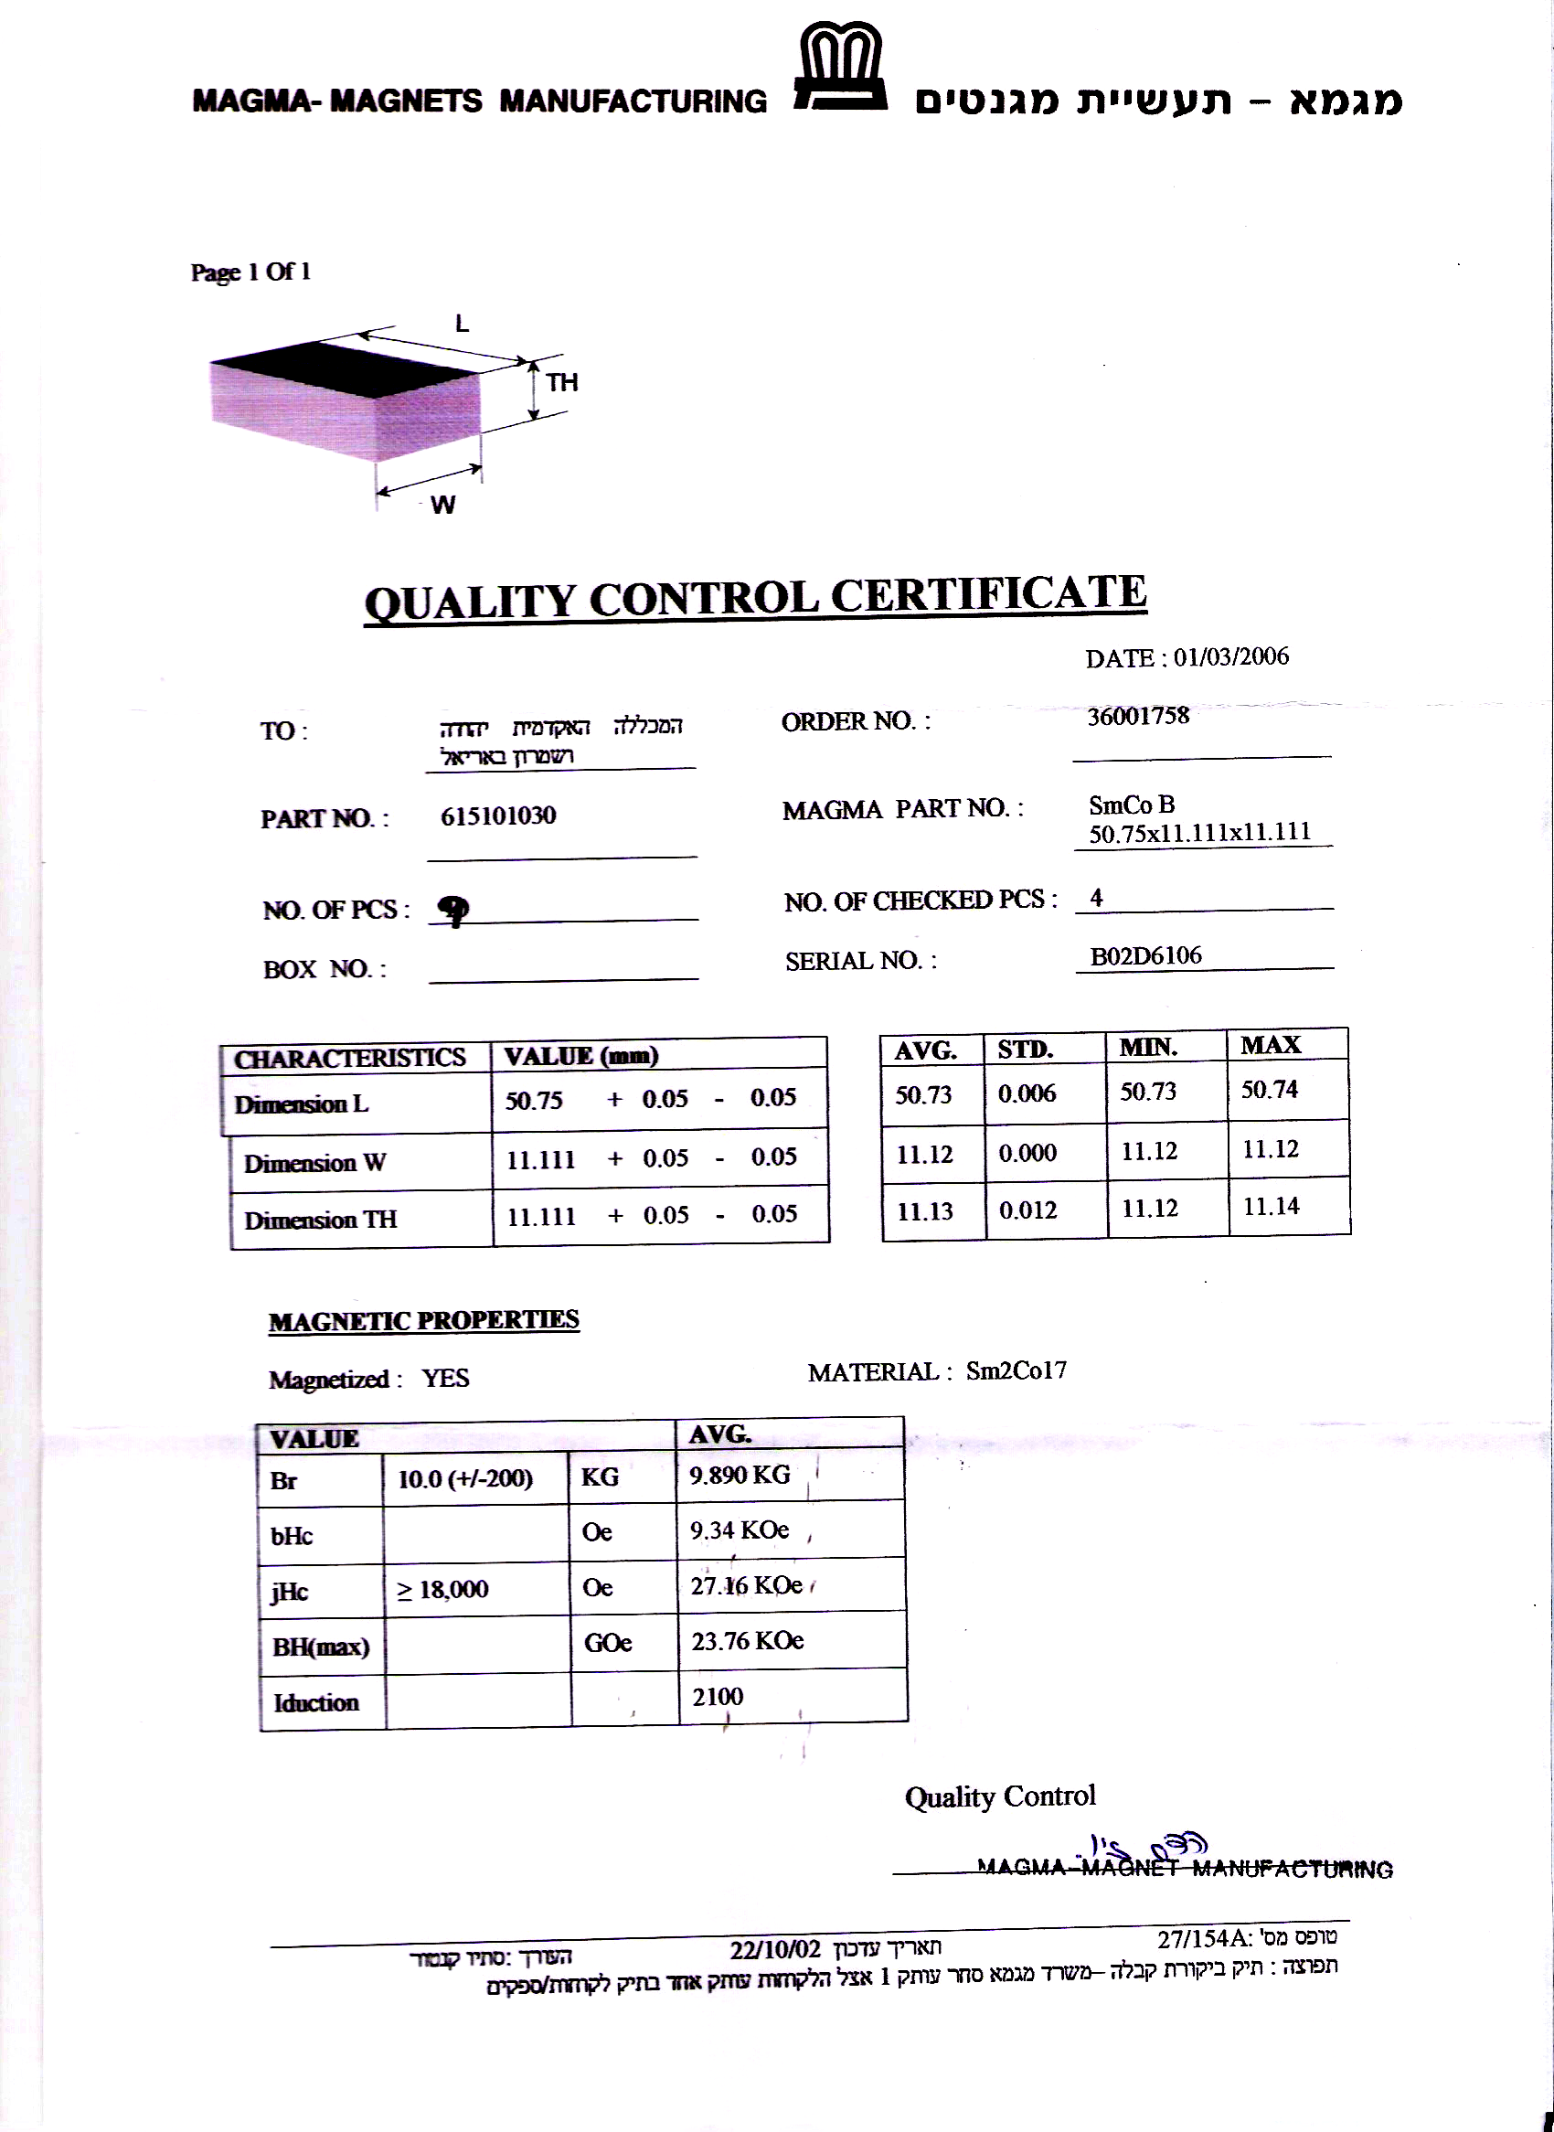
Group C
Calculated  Br [KG] | Measured field [KG] | Magnet name
8.23 | 1.925 | - C020
8.20 | 1.918 | - C021
8.13 | 1.9 | - C022
8.24 | 1.926 | - C023
8.21 | 1.92 | - C024
8.19 | 1.915 | - C025
8.15 | 1.905 | - C026
8.16 | 1.907 | - C027
8.30 | 1.94 | - C028
8.13 | 1.9 | - C029
8.24 | 1.926 | - C030
8.17 | 1.911 | - C031
8.12 | 1.898 | - C032
8.12 | 1.898 | - C033
8.25 | 1.93 | - C034
8.14 | 1.904 | - C035
8.24 | 1.927 | - C036
8.20 | 1.917 | - C037
8.27 | 1.934 | - C038
8.29 | 1.938 | - C039

Measurement statistics:

Average – 8.1988 KG
Std deviation – 0.0567 KG

Group C specifications (manufacturer's certificate):

